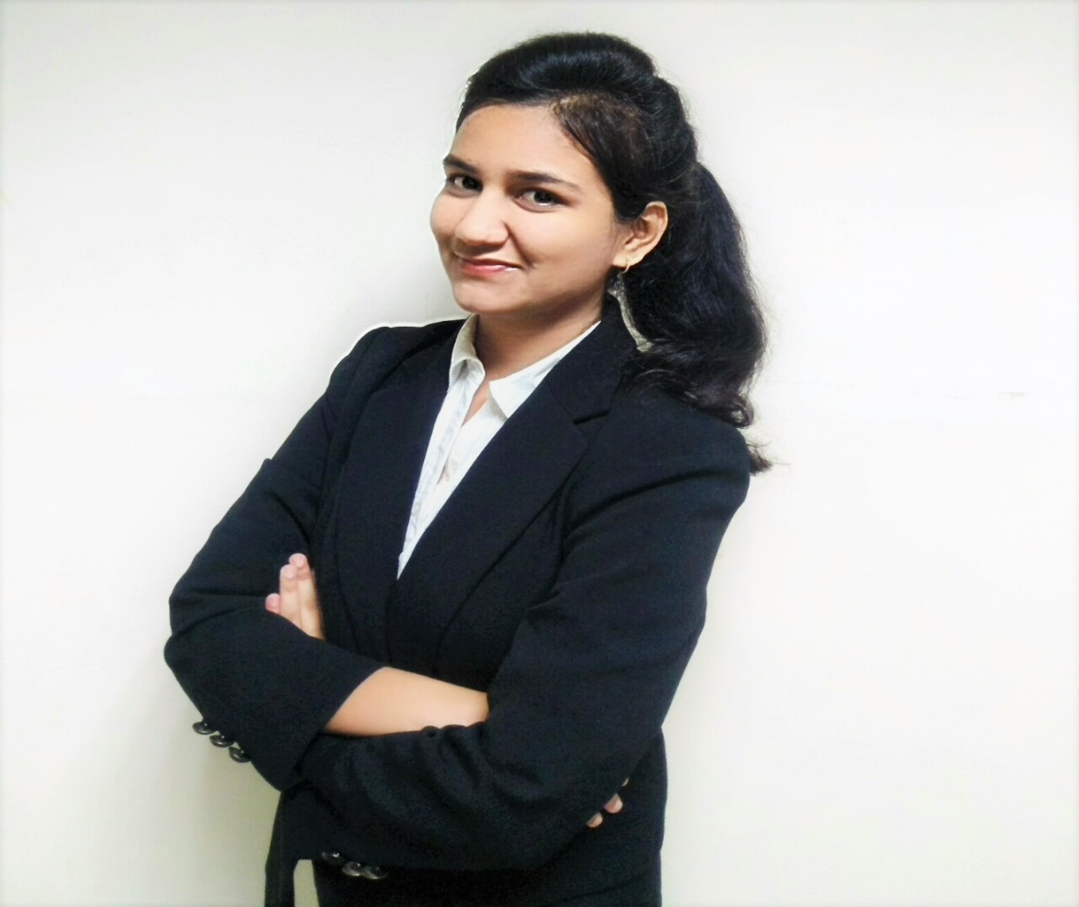

* Bachelor of Technology, Computer Science Engineering- Business Analytics and Optimisation with IBM
* A Data Science and Machine Learning enthusiast, passionate about learning new things and their practical implementation.
* Multi-functional team-player with proven leadership and analytical skills

SOMYA DWIVEDI

* WEBSITE DEVELOPMENT  
  Developed a web repository for source code and personal document.
* MACHINE LEARNING PROJECT  
  “Biometric Ear Recognition“ – Currently under development.

**mentor: Rajesh nath, dR. Madhulika**

Also worked on a live training project related to developing Elasticsearch based data model using Python. After 5 years down the line I would like to be an expert in data science related field that others can go for ideas, help and startegy. I’ve had amazing mentors so I’d like to provide similar guidance, potentially taking on a leadership role. Achieved 1st position for aptitude in Zenith-2018 and 3rd position in paper presentation hackathon on IBM ICE day. My interest also lies in working on Kaggle machine learning problems, reading articles on KDNuggets and Medium and connecting with different people of data science community and exploring their work. In all I’m an initiator and quick learner with proven analytical and aptitude skills.

A Research Fellowship holder and an enthusiast passionate about data science and machine learning, having a knack towards data mining, statistics, analytics and business intelligence. I am a dedicated learner who wants to stay relevant with the upcoming technologies and always keen to experience its real world applications. My favoured programming languages include Python, R, C, C++, including web development with HTML, CSS and basic Javascript. Currently working on Biometric Ear Recognition using Machine Learning. Worked as a web development trainer during summer internship and also published a research paper related to IOT and big data during the same.

GET TO KNOW ME THROUGH MY EYES OF THOUGHTS

PROJECTS & ACCOLADES

* MACHINE LEARNING  
  solved various kaggle problems using different ML algorithms.
* DATASCIENCE  
  worked on research paper with big data and IOT.

SKILLS & STRENGTHS

**somyadwivedi21@gmail.com**